**DAIRY PRODUCTS DELIVERY SYSTEM**

The dairy products delivery system is a streamlined solution for efficient distribution of dairy goods. Leveraging modern logistics and technology, it ensures timely delivery of fresh dairy products to customers' doorsteps. With optimized routes and real-time tracking, it enhances customer satisfaction while reducing operational costs. This system integrates order management, inventory tracking, and delivery scheduling to meet the demands of a dynamic market. Its user-friendly interface and seamless communication facilitate smooth coordination between suppliers, distributors, and end-users.

**DATA FLOW DIAGRAM**

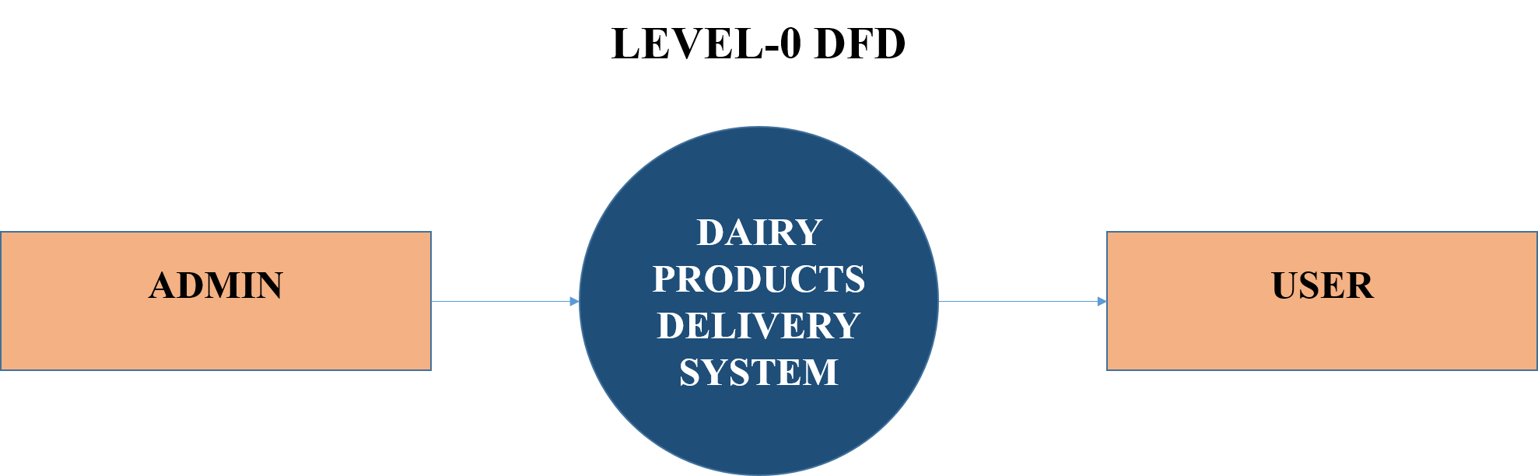

FIG 1 DATA FLOW DIAGRAM

**LEVEL 1 DFD**

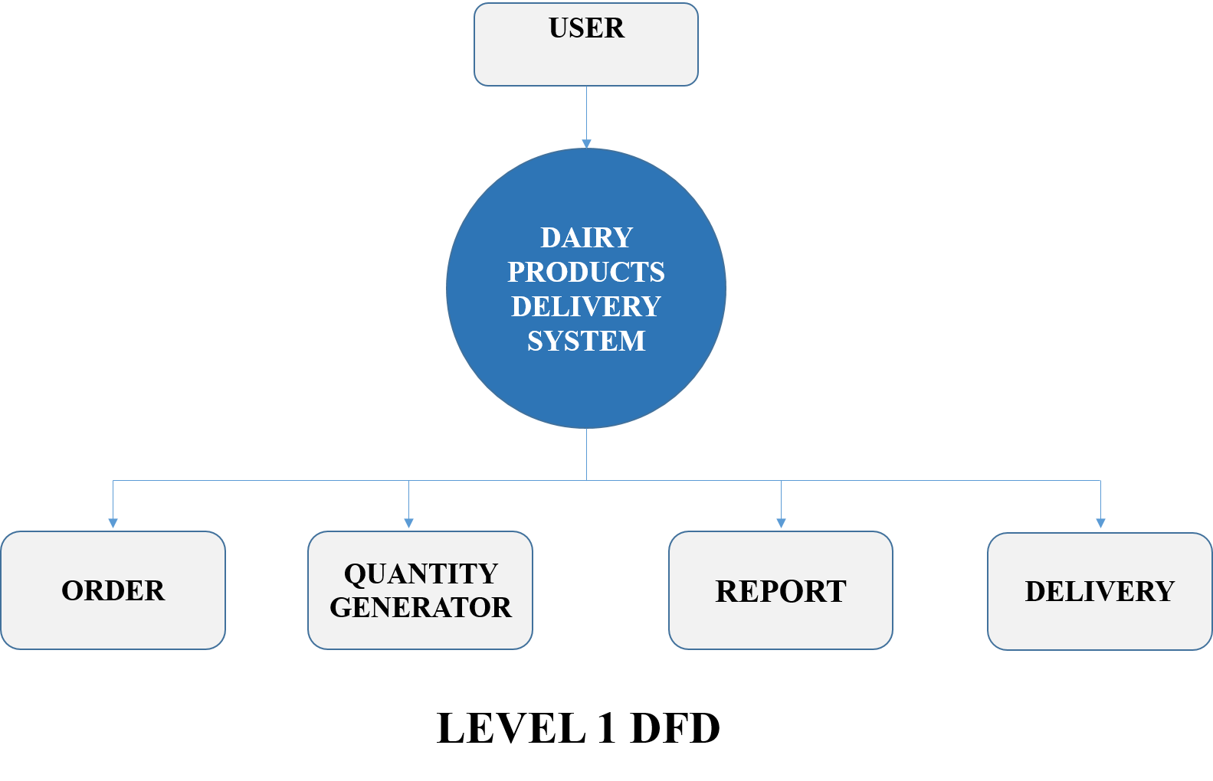

FIG 2 DATA FLOW DIAGRAM

**LEVEL 2 DFD**

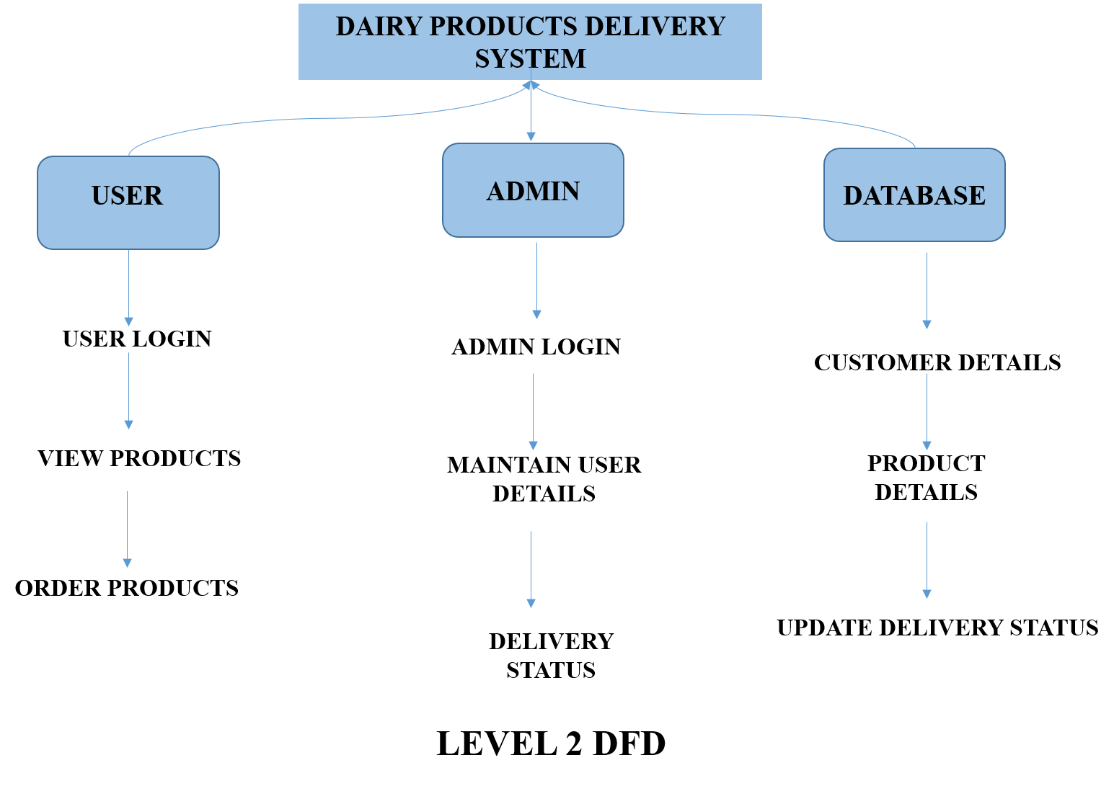

FIG 3 DATA FLOW DIAGRAM

**ENTITY RELATIONAL DIAGRAM**

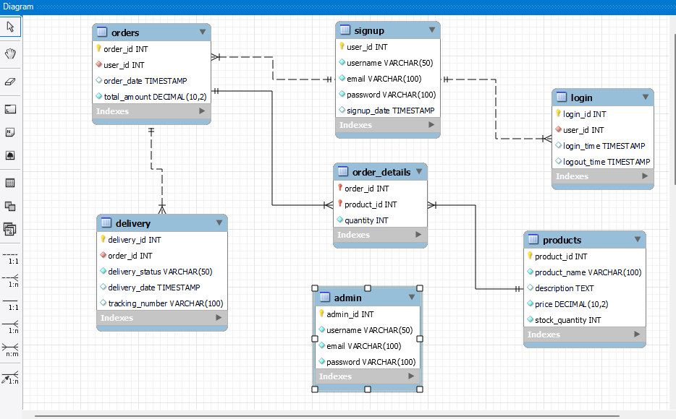

FIG 4 ENTITY RELATIONAL DIAGRAM